Phase 10: Deployment & Maintenance

Prepared by: Kukkadapu Venkata Naga Vasudha Ramyasri

Phase 10 is the final phase, focusing on deploying the Experience Cloud site into the production environment and establishing ongoing maintenance processes. This ensures that the site remains stable, secure, and continues to evolve with business needs after the initial launch.

**Step 1: Mobile Access**

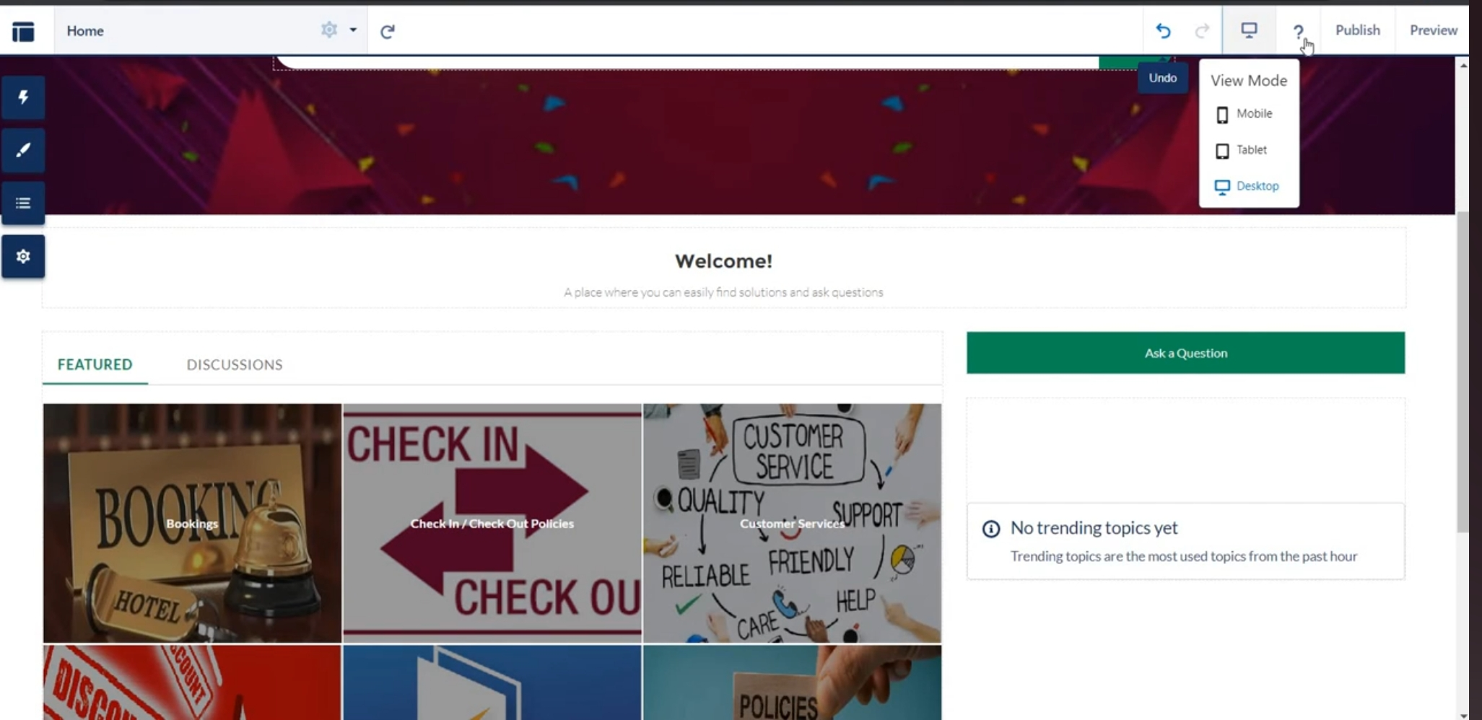

# Step 2: successfully Created Mobile Access

# 

# Step 3: assigning Audience for the Webpage

# 

# Step 4: Successfully Created Page

# 